**Security and Privacy in Online Social Network**

**Final Project**

**POLICIES:**

1. **Grade**

The final project accounts for 50% of the final grade, including class presentation 15% and final report 35%.

1. **Individual or Group**

Group based; a group consists of up to 4 students.

1. **Academic Honesty**

Violation of academic honesty may result in a penalty more severe than zero credit for an assignment, a test, and/or an exam.

1. **Submission**

Submit your *code, collected data (in .sql format), a report*, and *presentation PPT slides*, to course.zju.edu.cn

1. **Late Submission**

Deduction ceases upon zero;

Late submissions after 6:30pm on 6/16/2022 will NOT be graded.

**PROJECTS:**

1. **Arbitrage Betting**

Goal: Investigate the success chance of arbitrage betting in the real world

How: Continuously monitor several betting sites and collect the odds those sites place on the same sport events; Find a time window that arbitrage betting will succeed.

The following betting sites for your reference:

<https://sports.bet9ja.com/>

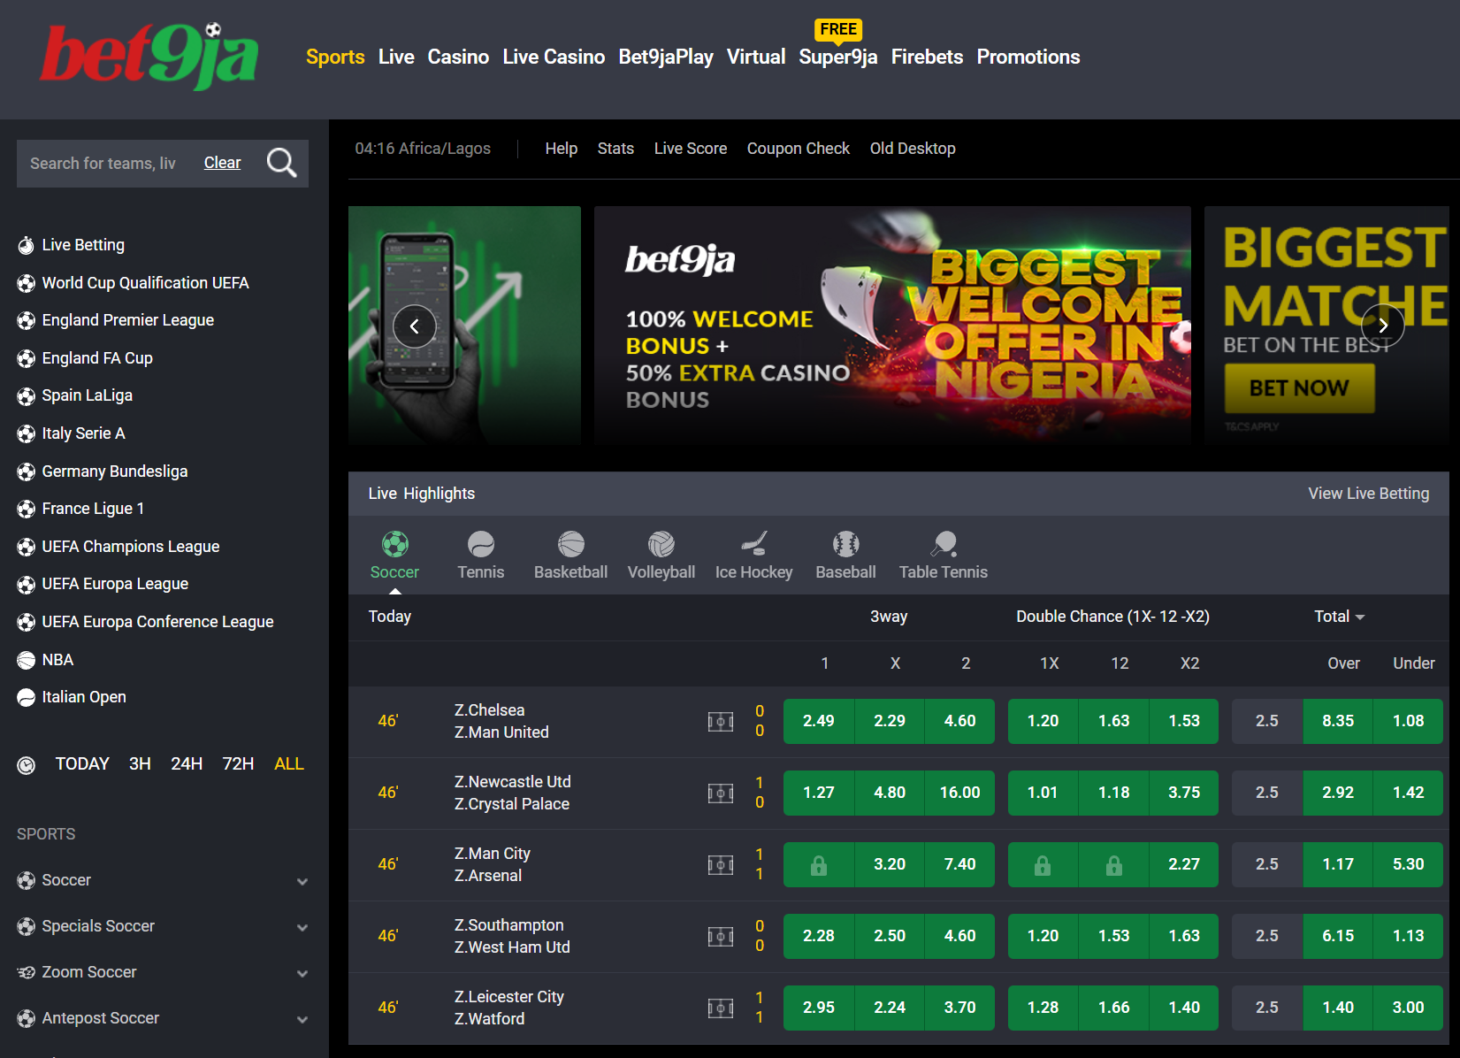

<https://sport.galera.bet/>

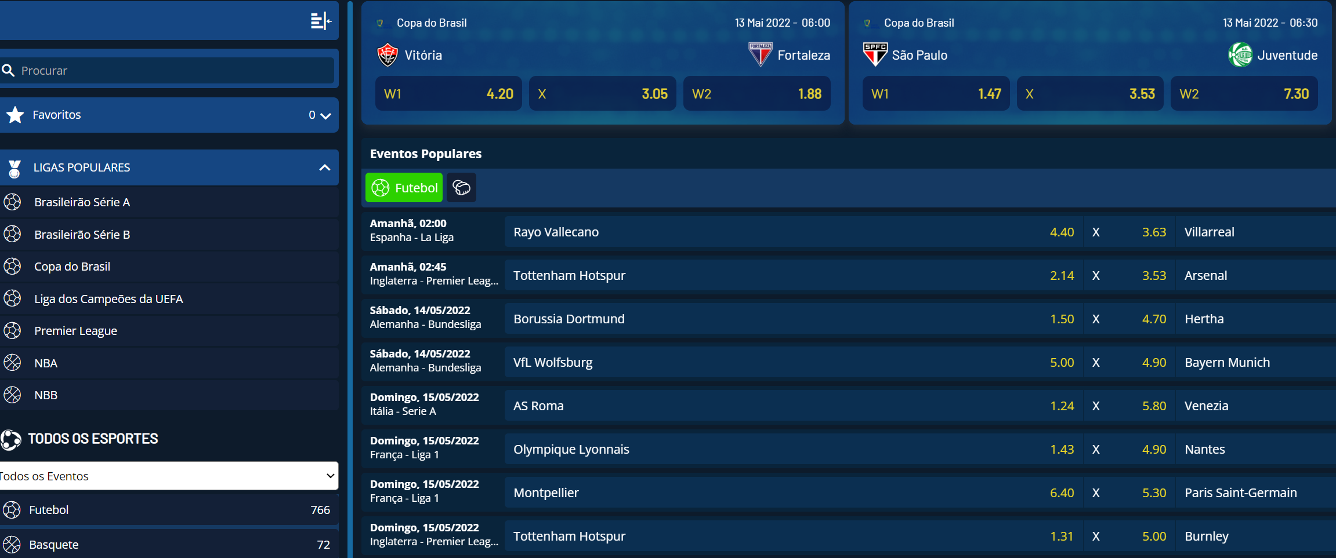

<https://betway.com/en/sports>

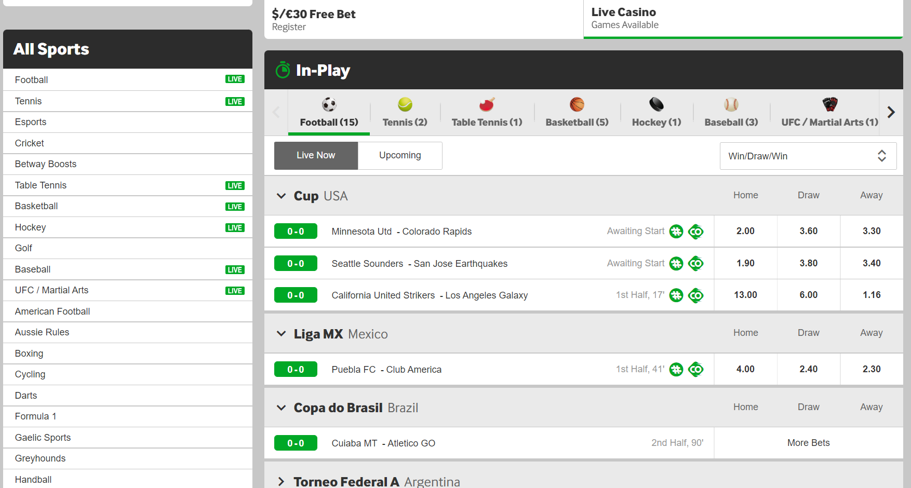

<https://www.forebet.com/>

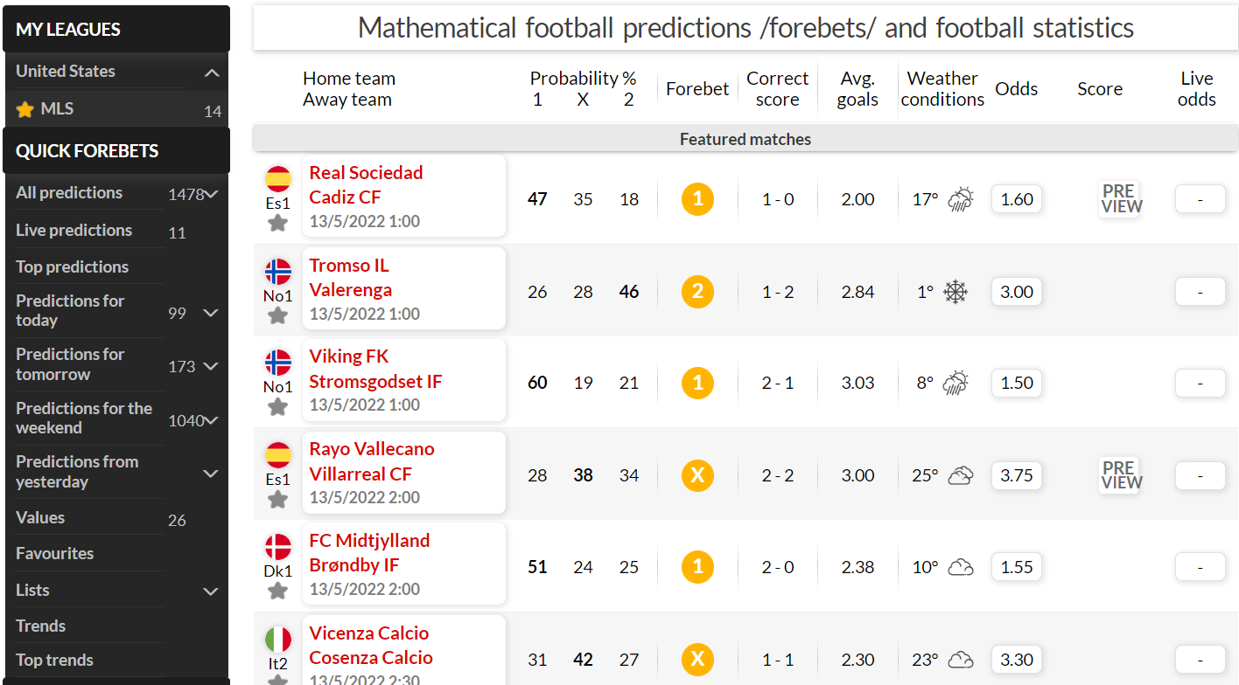

<https://www.sportybet.com/int/>

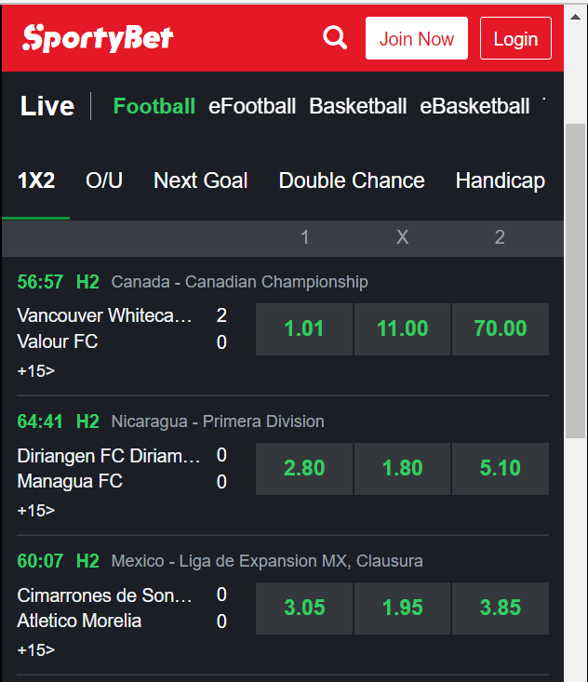

<https://www.iddaa.com/program/canli/basketbol?muk=4_71,4_673,4_606,4_286&m=false>

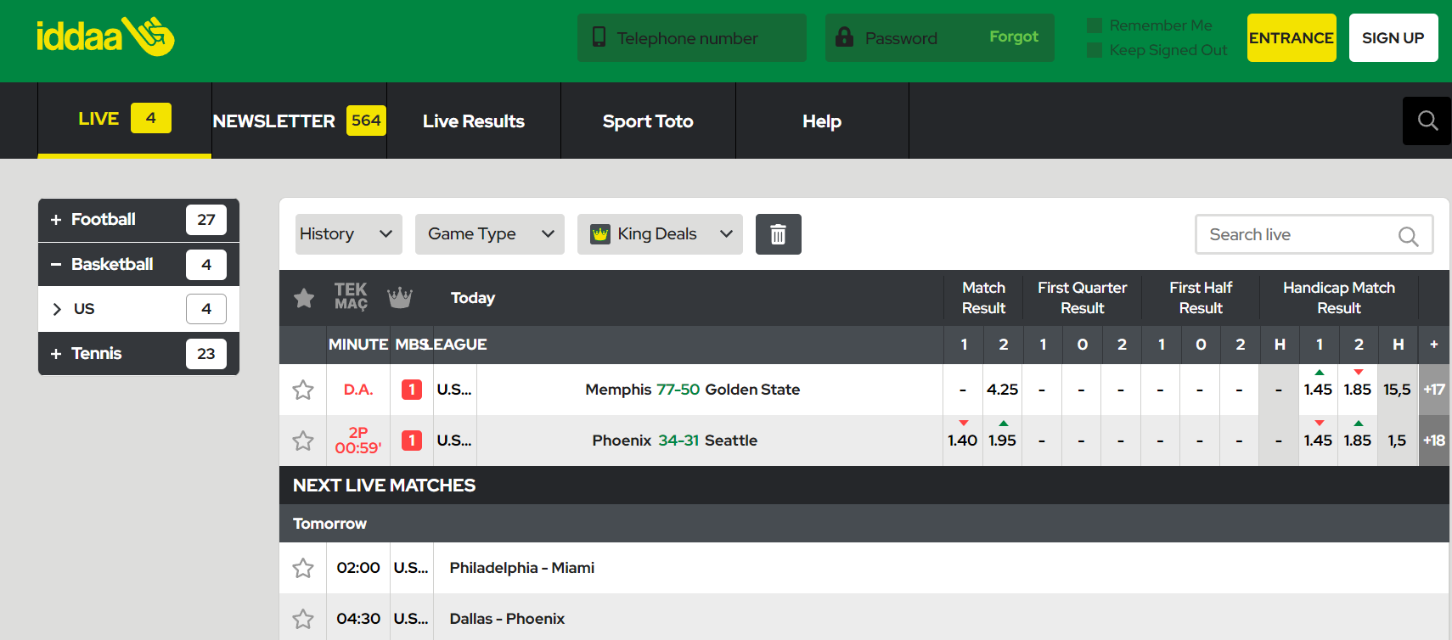

<https://www.mybookie.ag/sportsbook/soccer/>

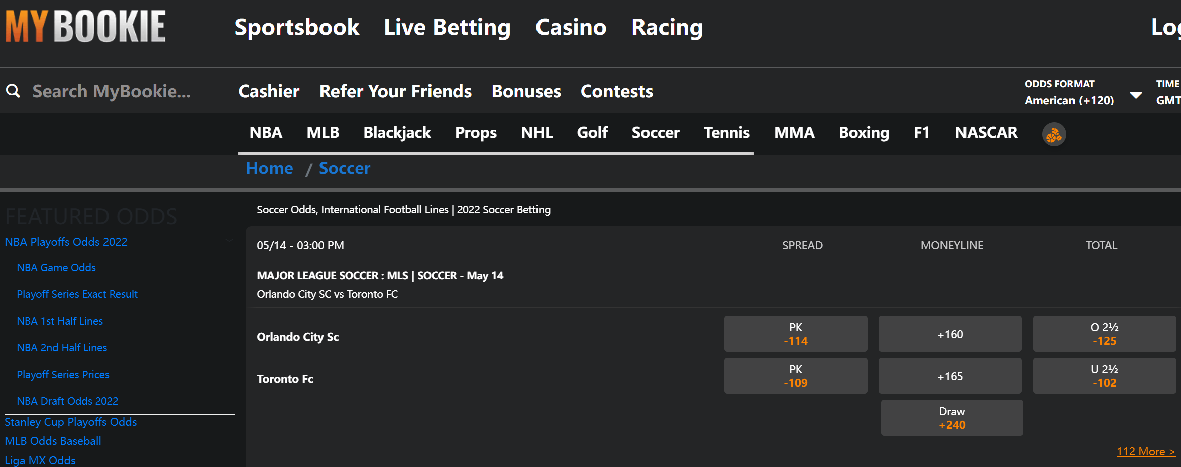

<https://pixbet.com/prejogo/?change_lang=1>



<https://www.betway.co.za/sport/soccer>

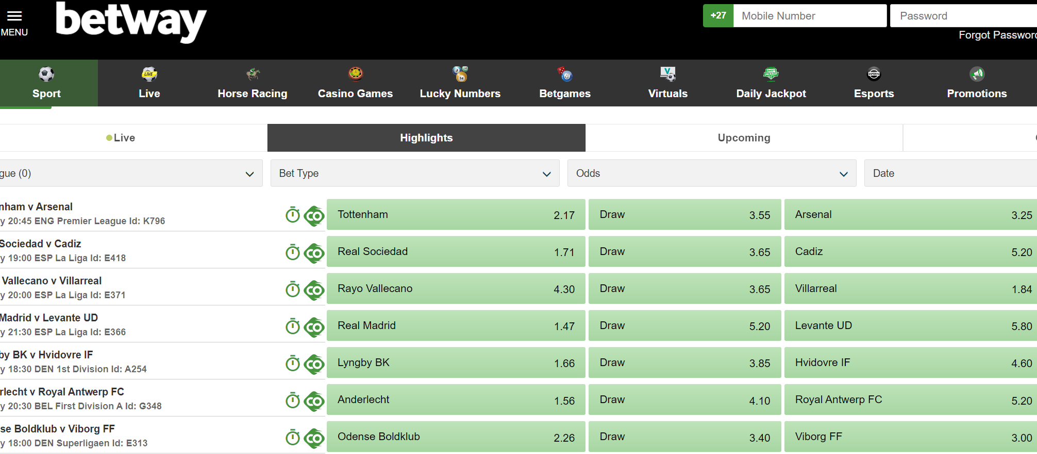

<https://sports.ladbrokes.com/sport/football/matches/today>

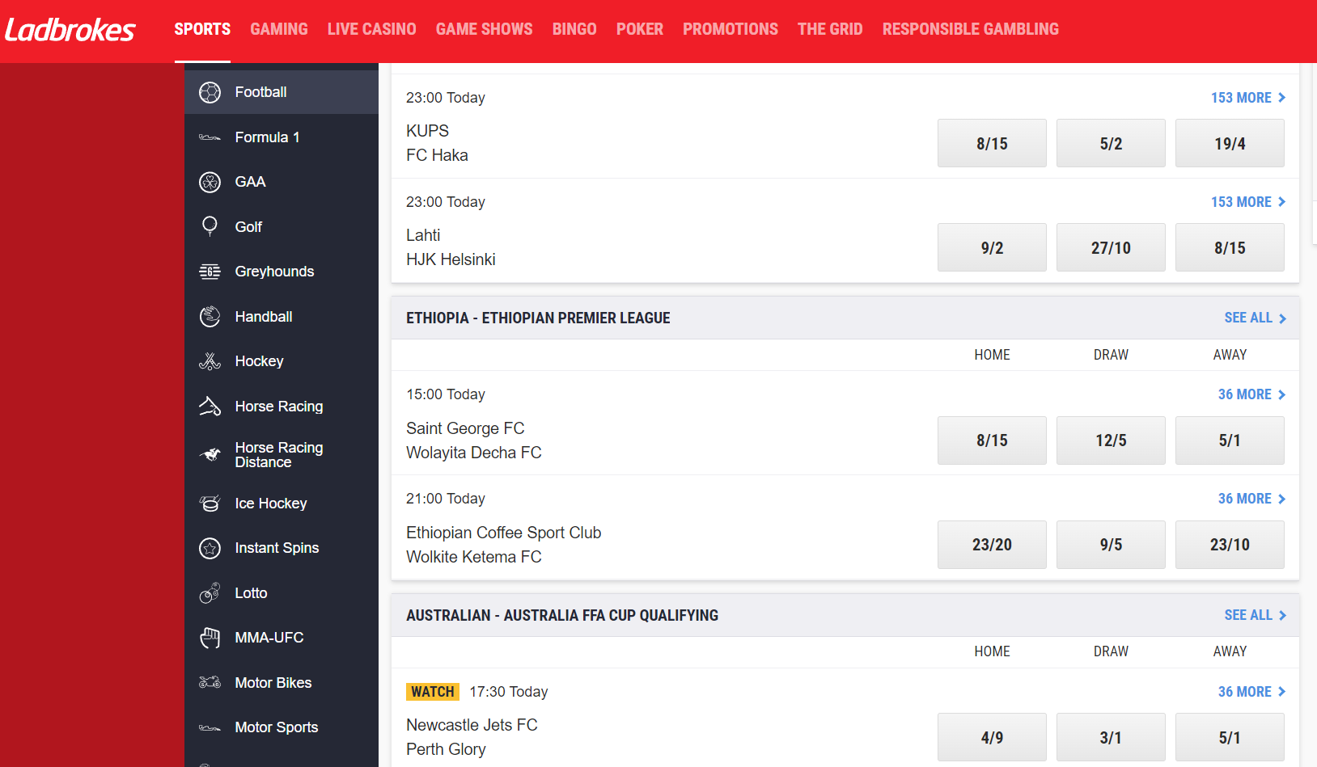

<https://www.888scoreonline.com/>

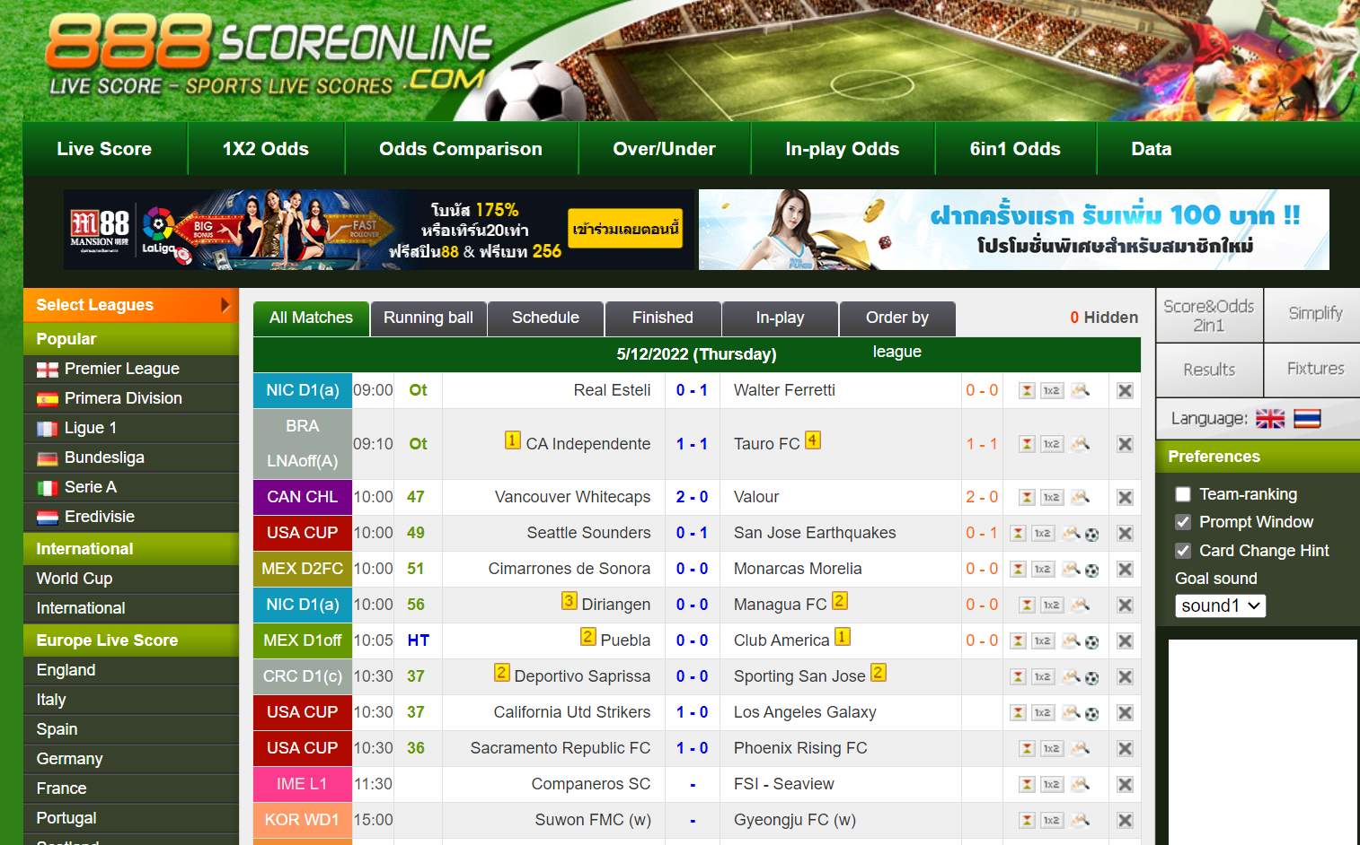

1. **Proxy Traffic Analysis:**

iproyal.com

Goal: to study

1. **Set up the environment**
2. Sign up with iproyal.com: <https://pawns.iproyal.com/register>

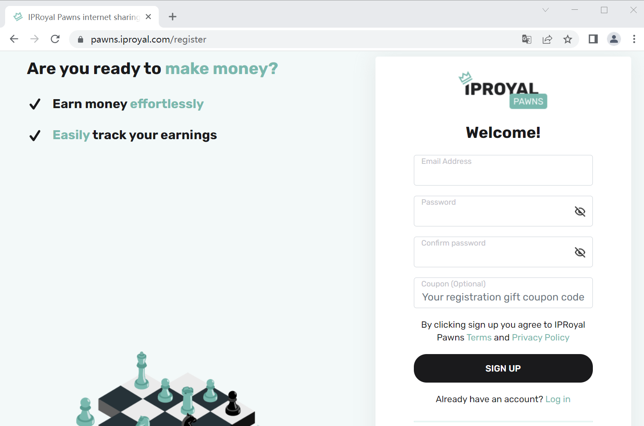

1. Verify your email address by clicking on the button in the email you received

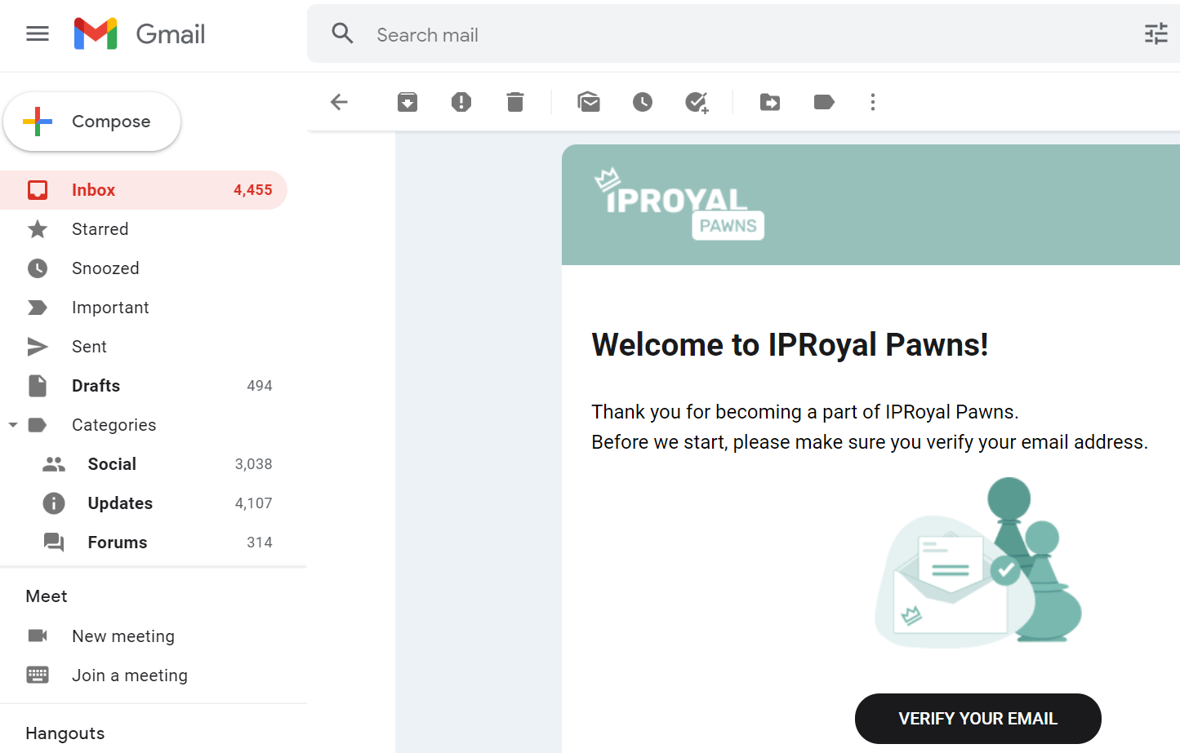

1. Download the app/software for Windows (IPRoyalPawnsSetup.exe), and watch the short YouTube video: [How to start earning money with IPRoyal PAWNS? - Passive Way to Earn Money - YouTube](https://www.youtube.com/watch?app=desktop&v=0_PnxOZtllw)

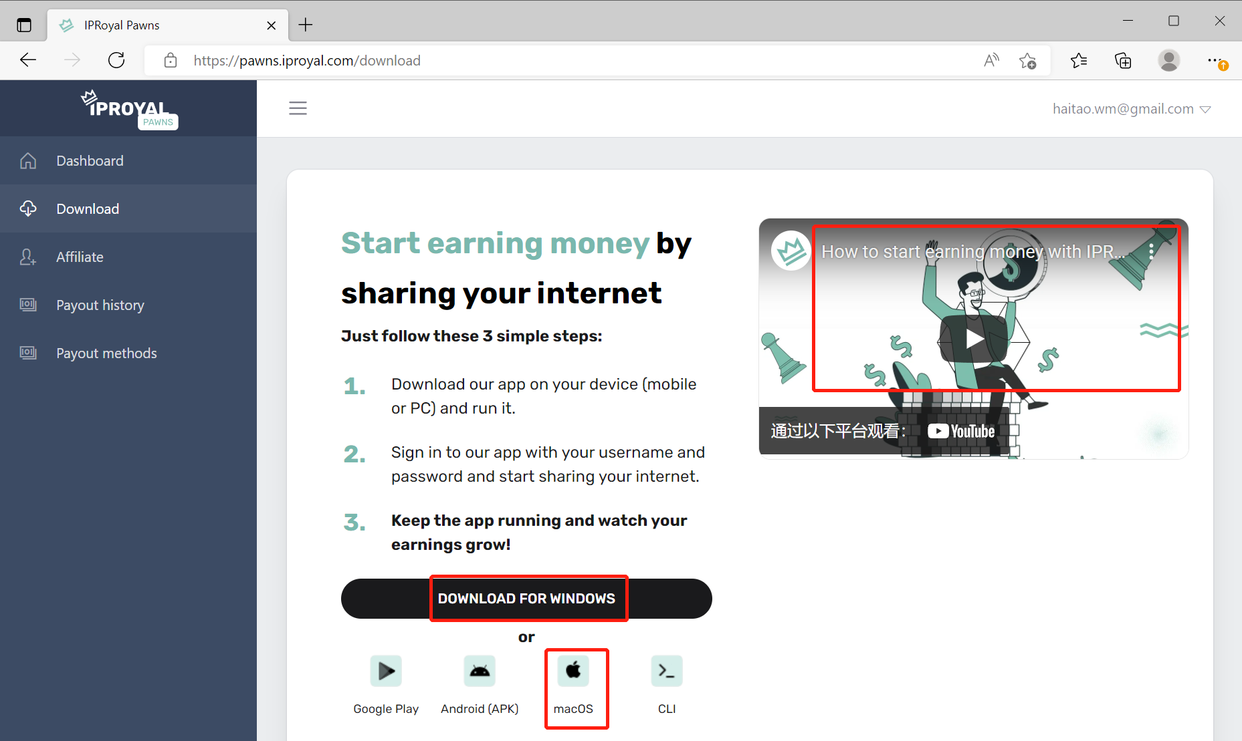

1. Install a VM on your computer
2. Install the app you downloaded in the VM
3. **Do static analysis on the app (.exe or .dmg)**
4. Upload the app to <https://www.virustotal.com/>, study the returned result, and look for any interesting findings. 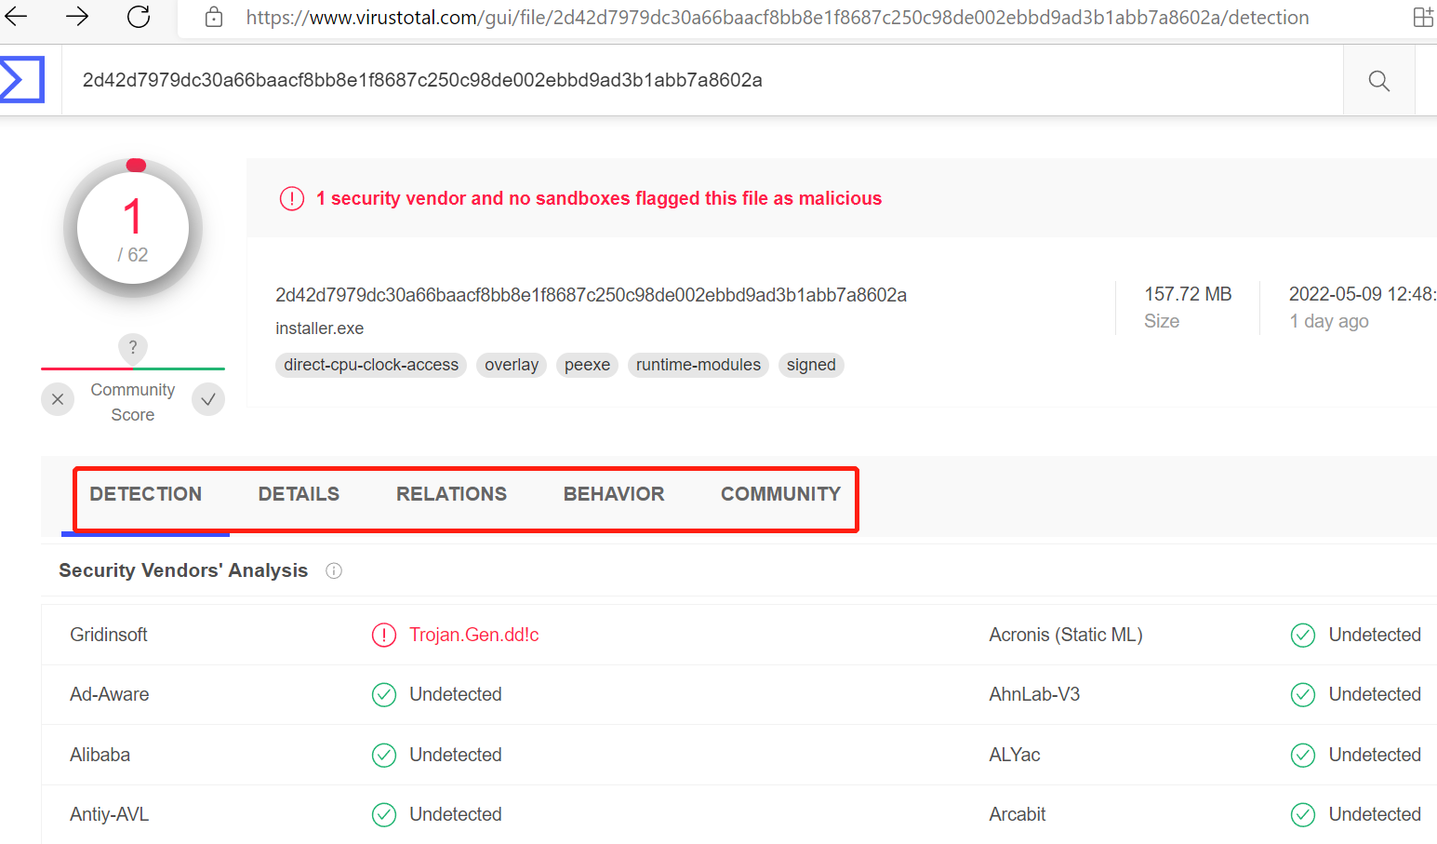
5. Use the tools (Hexdump, Strings, and etc.) listed in the following link for further static analysis. Note that you can do this analysis in a different machine than the vm. [CS6038/CS5138 Malware Analysis, UC by ckane](https://class.malware.re/2020/02/04/exe-file-analysis-1.html)
6. **Traffic Analysis, Dynamic Analysis**
7. Install and run Process Explorer ([Process Explorer - Windows Sysinternals | Microsoft Docs](https://docs.microsoft.com/en-us/sysinternals/downloads/process-explorer)) in VM
8. Install and run Wireshark in VM
9. Run the app
10. Use Wireshark to monitor the network traffic for about one week, and do analysis
11. Use Process Explorer to monitor the process of the app using Process Monitor, and do analysis

YouTube materials for your reference:

1. VirusTotal: [Advanced VirusTotal Tutorial | Learn Cybersecurity - YouTube](https://www.youtube.com/watch?v=Sf2UdT53yFw)
2. Hexdump: [showing actual file bytes with hexdump (beginner - intermediate) anthony explains #224 - YouTube](https://www.youtube.com/watch?v=FNyo1CSxBrg)
3. Strings: [Malware Analysis Bootcamp - Extracting Strings - YouTube](https://www.youtube.com/watch?v=V3_vc7BO9lU)
4. Wireshark: [Learn Wireshark in 10 minutes - Wireshark Tutorial for Beginners - YouTube](https://www.youtube.com/watch?v=lb1Dw0elw0Q)
5. Process Explorer: [Finding Malware with Sysinternals Process Explorer - YouTube](https://www.youtube.com/watch?v=y2bNLCWHFNs)
6. [5. Basic Dynamic Analysis (samsclass.info)](https://samsclass.info/126/proj/pDC5.htm)
7. **Image Privacy Protection**

Goal: Locate the privacy information in an image, and remove or mask that information.